HKCEM
JCM OSCE
AHNH
4 MAY 2016

Question 1

A 66 years old man presented with sudden low back pain and transient LOC while having a bath.
BP 92/50 P60
GCS 15/15
X ray of LS spine was taken.

- Comment on the x ray.
- What should be looked for on physical examination?
- What is the management in emergency department?

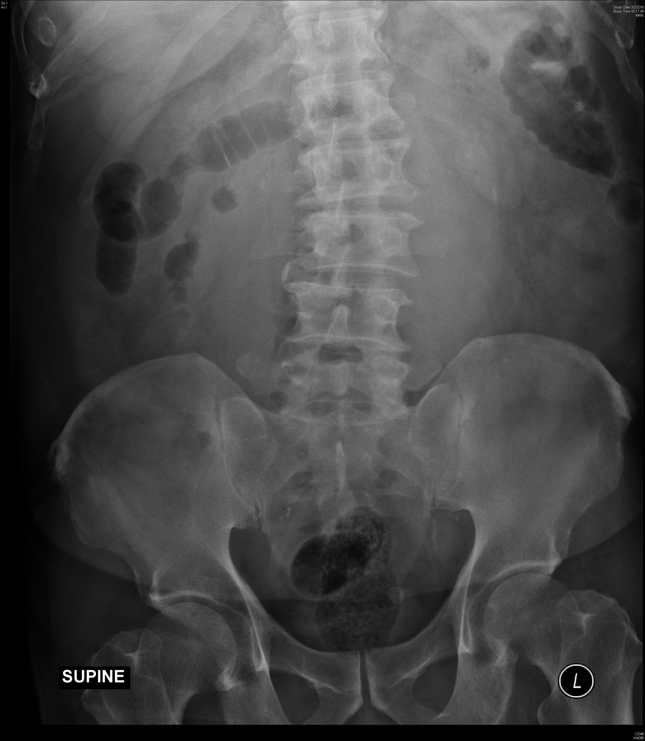

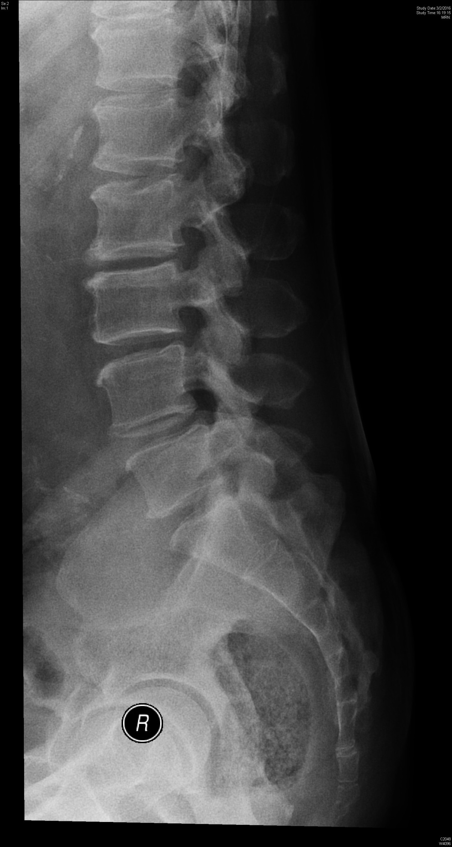
Question 2

An 81 years old bedridden elderly home lady was brought to emergency department for discolouration of her urinary bag.

- What is the diagnosis?
- What are the predisposing factors of the condition?
- What is the management in emergency department?

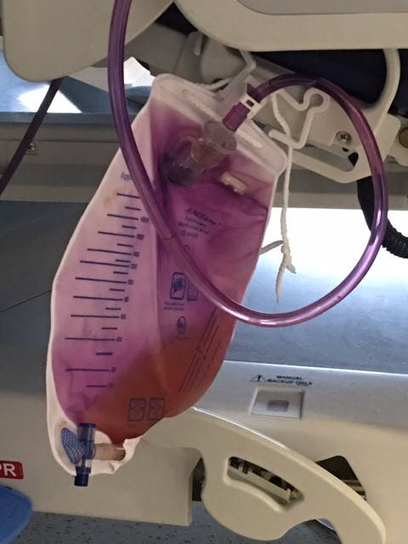
Question 3

A 32 years old man presented to emergency department by ambulance for numbness at ulnar border of right forearm and hand for 1 hour. The patient also complained of swelling of right forearm and right side chest pain. Physical examination does not reveal swelling of forearm or neurological deficit.

Plain CT head was performed.

- Describe the CT head.
- What are the differential diagnoses?
- What is the management in emergency department?
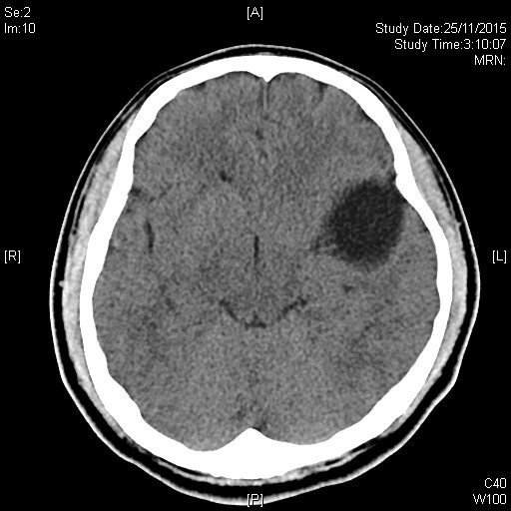
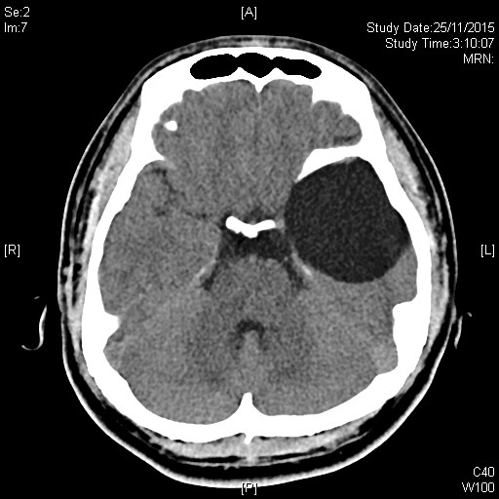
Question 4

An 81 years old demented elderly home resident took 150ml of cough mixture A and 50ml cough mixture B of another resident 2 hours ago.
BP 145/90 P56
GCS 15/15

- What should be looked for on physical examination?
- What investigations are indicated?
- What is the management in emergency department?
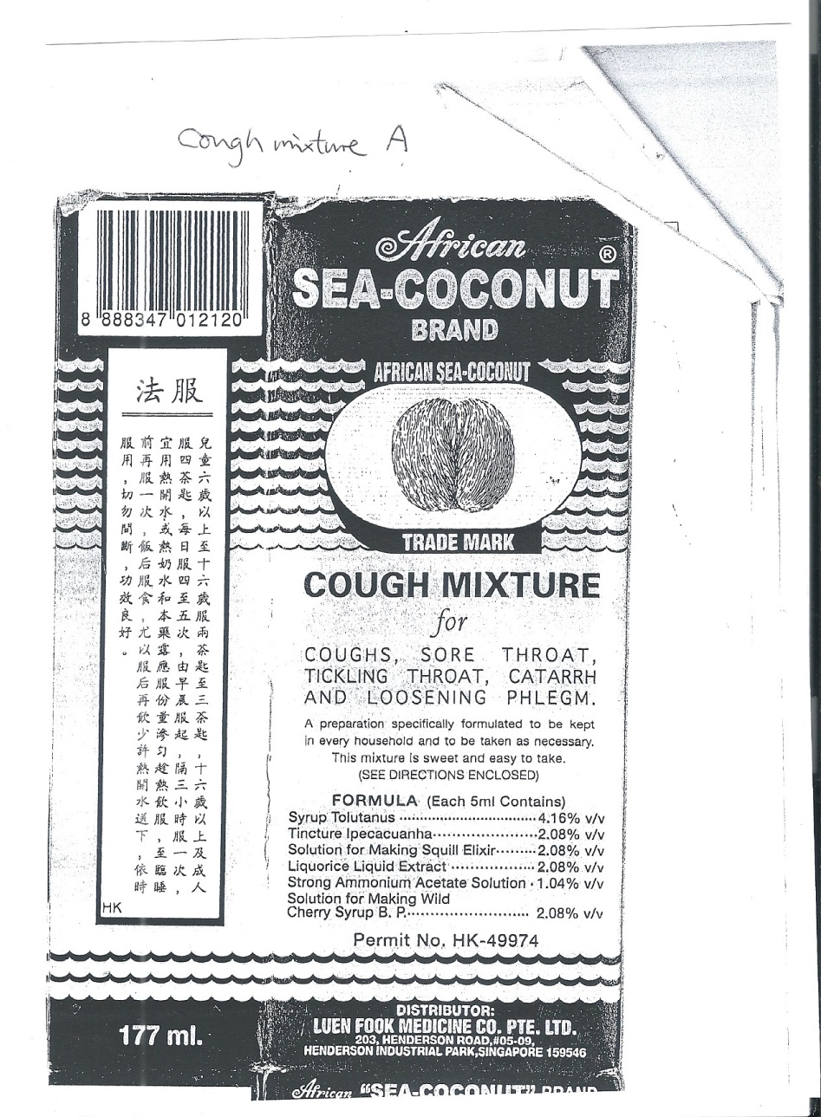

Question 5

A 34 years old man presented to A&E with vomiting and SOB for few hours. He also complained of left side chest pain.

BP 105/65 P 128
T 38
SpO2 95
GCS 15/15

- Comment on the CXR.
- What are the differential diagnoses?
- What is the management at emergency department?
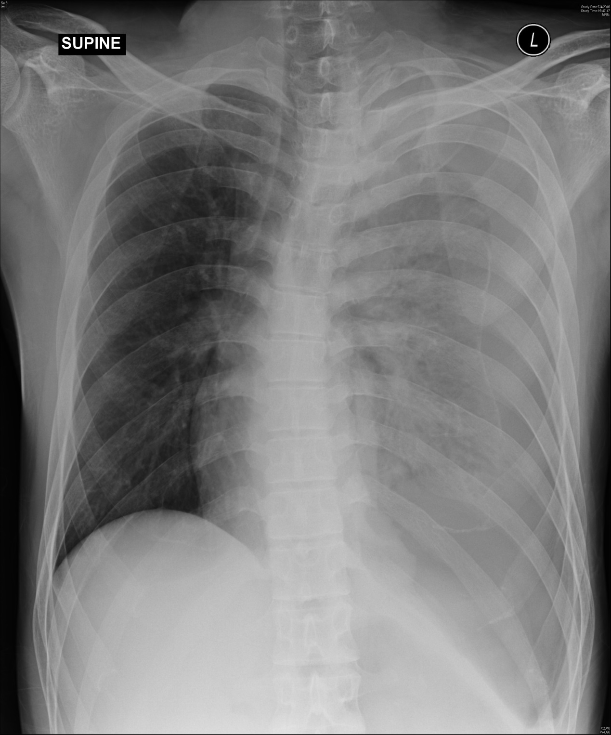

The end

